B. M. S College of Engineering (Autonomous)
Bangalore, Bull Temple Road – 560019
(Approved By AICTE, New Delhi and Affiliated to Visvesvarya Technological University, Belgavi)



B.E – [II year] [III sem]

Laboratory Manual
For
[Programming with C++]

Prepared by
[Sreelatha R, Rajeshwari K]

Department of
Information Science and Engineering

- Guidelines to the Students

- Equipment in the lab for the use of student community. Students need to maintain a proper decorum in the computer lab. Students must use the equipment with care. Any damage caused is punishable.
- Students are instructed to come to lab on time
- Students are supposed to occupy the systems allotted to them and are not supposed to talk or make noise in the lab.
- Students are required to carry their observation book with completed exercises while entering the lab.
- Students are not supposed to use pen drives in the lab without the permission of the lab technical staff.

- Course Objectives:

CO1: Able to understand the concepts of Object Oriented Programming with C++
CO2 : Develop C++ programs to overload functions and operators
CO3: Classify inheritance with the understanding of early and late binding
CO4: Understand the basics of exception handling and able to design real world applications
CO5: Design and develop file functionalities for storage

- Lab Outcomes
- able to apply inheritance, encapsulation using C++ programming features
- able to apply overloading of operators, and functions
- able to apply and understand exceptions and file operations

- Recommended System/Software Requirements
gcc/ Linux/Codeblocks

- Introduction to the Subject: (Three Paragraphs)

C++ introduces object-oriented programming (OOP) features to C. It offers classes, which provide the four features commonly present in OOP (and some non-OOP) languages:abstraction, encapsulation, inheritance, and polymorphism. One distinguishing feature of C++ classes compared to classes in other programming languages is support for deterministic destructors, which in turn provide support for the Resource Acquisition is Initialization (RAII) concept.

Encapsulation is the hiding of information to ensure that data structures and operators are used as intended and to make the usage model more obvious to the developer. C++ provides the ability to define classes and functions as its primary encapsulation mechanisms. Within a class, members can be declared as either public, protected, or private to explicitly enforce encapsulation. A public member of the class is accessible to any function. A private member is accessible only to functions that are members of that class and to functions and classes explicitly granted access permission by the class ("friends"). A protected member is accessible to members of classes that inherit from the class in addition to the class itself and any friends.

Inheritance allows one data type to acquire properties of other data types. Inheritance from a base class may be declared as public, protected, or private. This access specifier determines whether unrelated and derived classes can access the inherited public and protected members of the base class. Only public inheritance corresponds to what is usually meant by "inheritance". The other two forms are much less frequently used. If the access specifier is omitted, a "class" inherits privately, while a "struct" inherits publicly. Base classes may be declared as virtual; this is called virtual inheritance. Virtual inheritance ensures that only one instance of a base class exists in the inheritance graph, avoiding some of the ambiguity problems of multiple inheritance.

- List of Experiments:

Sl.No | Name of the Program
1 | Write a class named Employee that has the following member variables: Name, idNumber, department, position. Write appropriate constructors. Write appropriate mutator functions that store values in these member variables and accessor functions that return the values in these member variables. Write a program that creates three Employee objects to hold the following data.
  Name | ID number | Department | Position
  A | 121 | Accounting | VP
  B | 122 | IT | Programmer
  C | 123 | Manufacturing | Engineer
2 | Create a class called time that has separate int member data for hours, minutes and seconds. One constructor should initialize this data to 0, and another should initialize it to fixed values. Another member function should display it, in 11:59:59 format. The final member function should add two objects of type time passed as arguments. And also use operator overloading concept to show add operation.  A main () program should create two initialized time objects, and one that isn’t initialized. Then it should add the two initialized values together, leaving the result in the third time variable. Finally it should display the value of the third variable.
3 | Design a Ship class with following members: name, year, constructor, accessors and mutators. A virtual print function that displays the ship’s name and year it was built.  Design a CruiseShip class that is derived from Ship class and having members: maximum number of passengers, constructor, accessors and mutators and print function should display only the ship’s name and the maximum number of passengers.  Design a CargoShip class that is derived from Ship class and having members: cargo capacity in tonnage, constructor, accessors and mutators and print function should display only the ship’s name and Ship’s cargo capacity. Demonstrate the classes in a program that has an array of ship pointers. The array elements should be initialized with the addresses of dynamically allocated Ship, CruiseShip, CargoShip objects. The program should then step through the array, calling each object’s print function.
4 | Create a Distance class with feet and inches in public section. For default constructor assign both members to 0. For parameterized constructor, when the inch is equal or exceeds 12, throw an exception and display error message. Similarly for the mutator. The exception handler should be defined in the main() program.
5 | Write a program that uses a structure to store the following inventory data in a file: Item Description, Quantity, WholeSaleCost, RetailCost, DateaddedtoInventory. The program should have a menu that allows the user to perform the addition of new records to file and display of the records from file.

- Solutions:

Sl.No | Name of the Program
1 | Title:  Write a class named Employee that has the following member variables: Name, idNumber, department, position. Write appropriate constructors. Write appropriate mutator functions that store values in these member variables and accessor functions that return the values in these member variables. Write a program that creates three Employee objects to hold the following data.  Objective of the given problem:  - To learn mutator, accessor functions with objects of class  Problem Analysis:  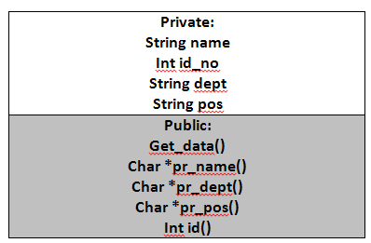  Algorithm  A class emp with the following template was created  - A default and parameterized constructor was defined  - three objects e1,e2,e3 of type emp was created.  - e1 called through default constructor,e2 through parameterized constructor and e3 through access of member functions  - data of all 3 objects displayed through member functions  Output expected.  Enter the name : A  Enter the dept : Accounting  Enter the pos : VP  Enter the ID : 121  Discussion and conclusion :  The student understands creation of the object, with an array allocation and access the member functions using loop construct.
  Name | ID number | Department | Position
  A | 121 | Accounting | VP
  B | 122 | IT | Programmer
  C | 123 | Manufacturing | Engineer
2 | Title:  Create a class called time that has separate int member data for hours, minutes and seconds. One constructor should initialize this data to 0, and another should initialize it to fixed values. Another member function should display it, in 11:59:59 format. The final member function should add two objects of type time passed as arguments. And also use operator overloading concept to show add operation.  A main () program should create two initialized time objects, and one that isn’t initialized. Then it should add the two initialized values together, leaving the result in the third time variable. Finally it should display the value of the third variable.  Objective of the given problem:  To learn what a constructor is, and also know operator overloading  Problem Analysis:  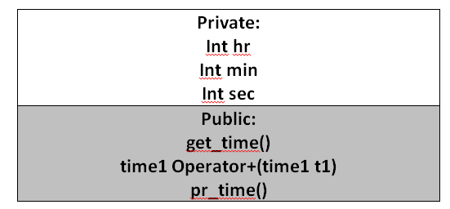  Algorithm  - A default and parameterized constructor was defined  - An operator overloaded module as a member function was defined (implicit operator overloading)  - Two objects t1, t2 were defined through constructors.  - Operator overloading was applied  - Result was displayed through pr_time()  Output expected.  T1 + T2 = 10 : 32 : 21  Discussion and conclusion :  The student understands creation of the object, understands the essence of operator overloading. The plus operator is overloaded and member functions are suitably instantiated.
3 | Title :  Design a Ship class with following members: name, year, constructor, accessors and mutators. A virtual print function that displays the ship’s name and year it was built.  Design a CruiseShip class that is derived from Ship class and having members: maximum number of passengers, constructor, accessors and mutators and print function should display only the ship’s name and the maximum number of passengers.  Design a CargoShip class that is derived from Ship class and having members: cargo capacity in tonnage, constructor, accessors and mutators and print function should display only the ship’s name and Ship’s cargo capacity. Demonstrate the classes in a program that has an array of ship pointers. The array elements should be initialized with the addresses of dynamically allocated Ship, CruiseShip, CargoShip objects. The program should then step through the array, calling each object’s print function.  Objective of the given problem:  Understand the concept of parent and child relationship. Know the meaning of redundancy. Therefore understand the essence of virtual keyword.  Problem Analysis:  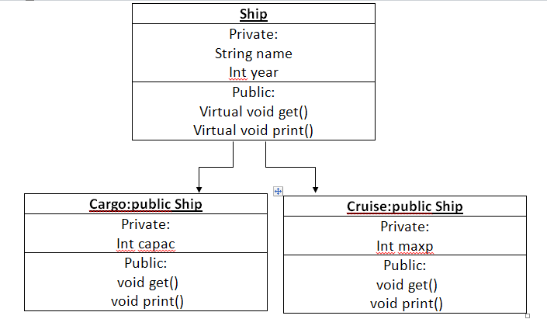  Algorithm  - A template of the following inheritance relationship was created  - three object of type ship, cruise, cargo were dynamically allocated the address to a ship array through new and delete function and constructors.  Output expected.  Cargo ship  Capacity : 100000  Name : MH 121  Year : 1999  Discussion and conclusion :  Creation of various types of objects and the reusability concepts. The inheritance model is exhibited. The virtual keyword is well understood. The dynamic assignment of the object is understood.
4 | Title :  Create a Distance class with feet and inches in public section. For default constructor assign both members to 0. For parameterized constructor, when the inch is equal or exceeds 12, throw an exception and display error message. Similarly for the mutator. The exception handler should be defined in the main() program.  Objective of the given problem:  Understand the concept of exception handling using the try, catch, block and some compiler defined exception handling.  Problem Analysis:  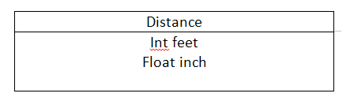  Algorithm:  - A class distance with members feet and inch was created  - Default and parameterized constructor was defined such that a throw statement defined to a catch block for printing error msg  - inside main(), a try block was defined.  - a catch function to define the message was defined  Output expected:  Enter the dist : 12 24  The inches is greater do enter it again  Discussion and conclusion :  The inch is been defined within the program, as well as a user input detail is asked. The cases are to be handled.
5 | Title :  Write a program that uses a structure to store the following inventory data in a file: Item Description, Quantity, WholeSaleCost, RetailCost, DateaddedtoInventory. The program should have a menu that allows the user to perform the addition of new records to file and display of the records from  Objective of the given problem:  - Understand the concepts of file handling  - Concepts of class been written to a file  - Class been read from the file  Problem Analysis:  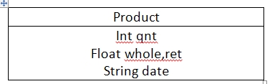  Algorithm  A structure of type product was defined as mentioned above.  - An ofstream object f1 was created to write to a binary file to “inventory.dat”  - An ifstream object f2 was created to read to a binary file from “inventory.dat”  Output expected:  Product details from the file  Quantity : 2  Whole Sale Cost: 50  Retail Cost : 55  Date added to Inventory: 24/3/2016  Discussion and conclusion :  Able to understand the details of the file operations, various types of file handlers, and file read/write operations for a class type.

